* 1. SELECT cname FROM Cooks WHERE dish = ‘lasagna’;
  2. SELECT dish FROM Cooks WHERE cname = ‘Alton’;
  3. SELECT cname FROM Chefs WHERE addr = ‘68 N Marietta Pkwy’;
  4. SELECT cname FROM Cooks WHERE dish = ‘tamales’ OR dish = ‘sopapillas’;
  5. SELECT cname, addr FROM Chefs, (SELECT cname FROM Cooks WHERE dish = ‘escargot’) CooksName WHERE Chefs.cname = CooksName.cname;
  6. SELECT DEPT#, BUDGET FROM DEPT;
  7. SELECT \* FROM DEPT WHERE DEPT# = ‘D1’ OR DEPT# = ‘D2’;
  8. SELECT \* FROM EMP, (SELECT \* FROM DEPT WHERE DEPT# = ‘D1’ OR DEPT# = ‘D2’) correctDept WHERE EMP.DEPT# = correctDept.DEPT#;
  9. SELECT EMP#, SALARY FROM EMP WHERE EMP# = ‘E1’ OR EMP# = ‘E4’;
  10. 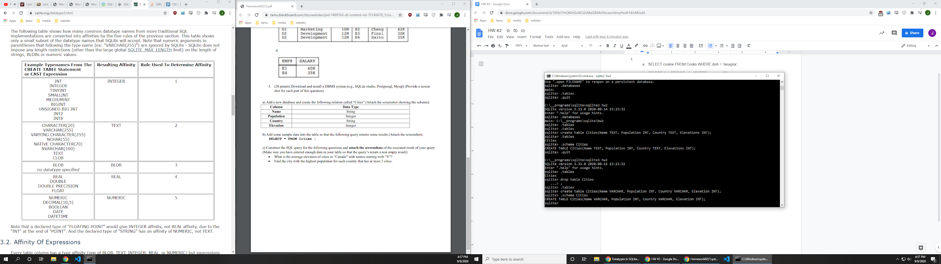
  11. 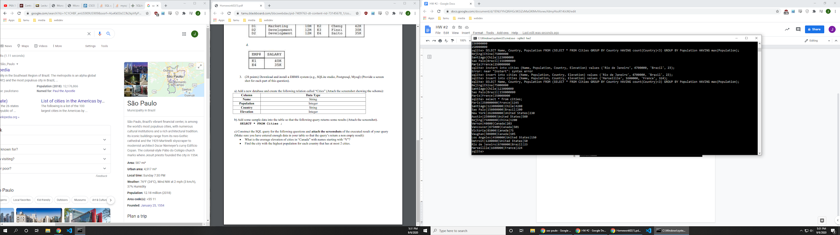
  12. 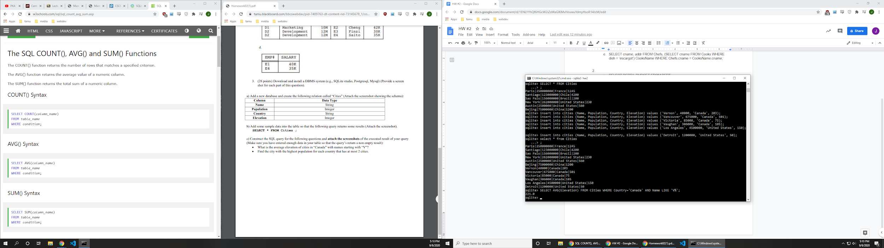  
      SELECT AVG(Elevation) FROM Cities WHERE Country='Canada' AND Name LIKE 'V%';

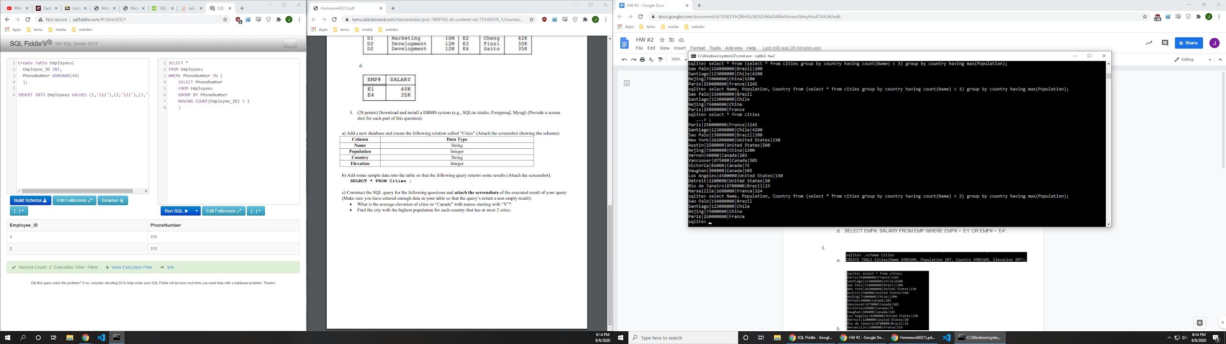select Name, Population, Country from (select \* from cities group by country having count(Name) < 3) group by country having max(Population);